**FAB LAB TOOLS**

1. **Bosch Professional GKS 190**

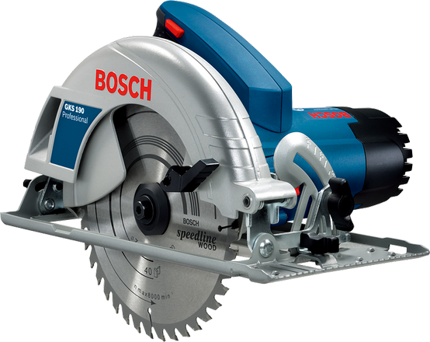

**INTENDED USE**

* The machine is intended for lengthways and Cross ways cutting of wood with straight cutting lines as well as mitre cuts in wood while resting firmly on the work piece.
* With suitable saw blades, thin-walled non-ferrous metals can also be sawed.
* Working ferrous metals is not permitted.

**Specifications**

1. Rated input power - 1,400 W
2. No-load speed - 5.500 rpm
3. Weight - 4.1 kg
4. Max. cutting capacity in wood (90°) - 67 mm
5. Max. cutting capacity in wood (45°) - 48 mm
6. Saw blade diameter - 184 mm

**Safety Precautions**

* Keep hands away from cutting area and the blade. Keep your second hand on auxiliary handle, or motor housing.
* Do not reach underneath the work piece.
* Never hold the work piece being cut in your hands or across your leg. Secure the work piece to a stable platform.
* Do not use dull or damaged blades.
* Always use blades with correct size and shape (diamond versus round) of arbor holes.
* Do not reach into the saw dust ejector with your hands.
* Always observe that the lower guard is covering the blade before placing saw down on bench or floor.

1. **Bosch Professional GCM 12 MX**

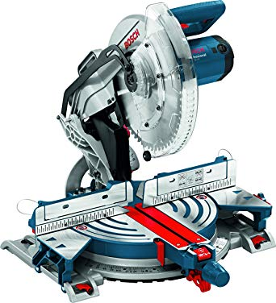

**INTENDED USE**

* The power tool is intended as a stationary machine for making straight lengthways and cross ways cuts in hard and softwood, as well as in particle and fibre board.
* In this, mitre angles from –52° to +52° as well as bevel angles from –2° to +47° are possible.
* When using appropriate saw blades, sawing aluminium profiles and plastic is also possible.

**Specifications**

1. Rated input power - 1800 W
2. No-load speed - 4.300 rpm
3. Weight - 20.5 kg
4. Saw blade Diameter - 305 mm
5. Cutting capacity - 91x187 mm

**Safety Precautions**

* Never stand on the power tool.
* Make sure that the guard operates properly and that it can move freely.
* Never remove cutting remainders, wood chips, etc. from the sawing area while the machine is running.
* Keep handles dry, clean, and free from oil and grease.
* Operate the power tool only when the work area to the workpiece is clear of any adjusting tools, wood chips,etc.
* Always firmly clamp the piece to be worked. Do not saw work pieces that are too small to clamp.
* Do not use high speed steel (HSS) saw blades.
* Always use blades with correct size and shape (diamond versus round) of arbor holes.

1. **Bosch Professional GBL 800 E**

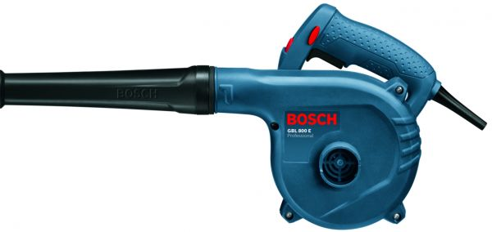

**INTENDED USE**

* The machine is intended for vacuuming and blowing of materials that are not hazardous to one's health.
* The machine is not suitable for vacuuming and blowing of flammable materials, metal chips and sharp objects, such as screws or nails.

**Specification**

1. Rated input power - 820 W
2. No-load speed - 16000 rpm
3. Weight - 1.8 kg
4. Volumetric flow rate - 4.5 m^s/min

**Safety Precautions**

* Do not vacuum and blow materials that are hazardous to one’s health, e. g., dust from beech or oak wood, masonry dust, asbestos.
* Do not vacuum and blow liquids.
* Keep the power tool away from rain or moisture.
* When operating the power tool in damp environments is unavoidable, use a residual current device (RCD).Never use the machine with a damaged cable.
* Do not touch the damaged cable and pull the mains plug when the cable is damaged while working.

1. **Bosch Professional GWS 900-100**

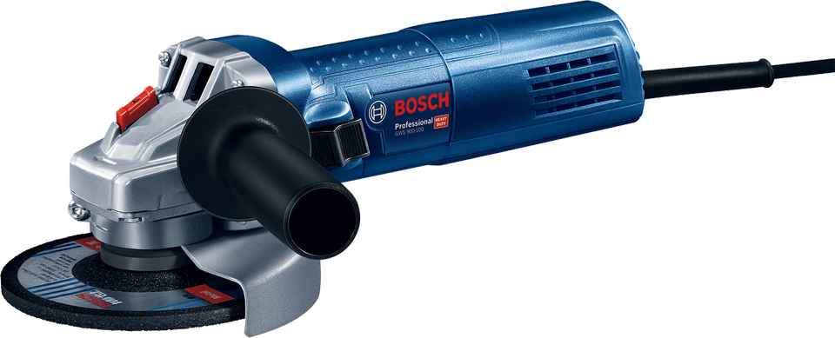

**INTENDED USE**

* The machine is intended for cutting, roughing and brushing of metal and stone materials without the use of water.
* For cutting with bonded abrasives, a special cutting guard (accessory) must be used.
* When cutting in stone, provide for sufficient dust extraction. With approved sanding tools, the machine can be used for sanding with sanding discs.

**Specification**

1. Rated input power - 900 W
2. No-load speed - 11000 rpm
3. Weight - 1.9 kg
4. Disc diameter - 100 mm
5. Switch - 2-way
6. Grinding spindle thread - M 10

**Safety Precautions**

* Operations such as polishing are not recommended to be performed with this power tool.
* Do not use accessories which are not specifically designed and recommended by the tool manufacturer.
* The rated speed of the accessory must be at least equal to the maximum speed marked on the power tool.
* The outside diameter and the thickness of your accessory must be within the capacity rating of your power tool.
* Threaded mounting of accessories must match the grinder spindle thread. For accessories mounted by flanges, the arbour hole of the accessory must fit the locating diameter of the flange.
* Do not operate the power tool near flammable materials.
* Do not use accessories that require liquid coolants.

1. **Bosch Professional GCO 14-24 J**

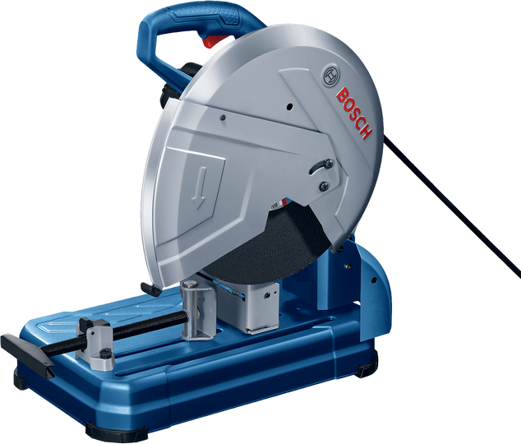

**INTENDED USE**

* The machine is intended for stationary use with cutting discs to perform lengthways and cross ways straight cuts or mitre cuts to 45° in metal materials without the use of water.

**Specifications**

1. Rated input power - 2400 W
2. No-load speed - 3800 rpm
3. Weight - 18.2 kg
4. Tool dimensions - 90 x 290 x 480 mm

**Safety Precautions**

* Always use the blade guard.
* Make sure that the guard operates properly and that it can move freely.
* Use the power tool only for dry cutting.
* Keep the mains cable away from rotating application tools.
* Keep handles dry, clean, and free from oil and grease.
* Never remove cutting remainders, metal chips, etc. from the cutting area while the machine is running.
* After switching off, do not stop the cutting disc by applying lateral pressure to it.
* Do not attach a saw chain woodcarving blade or toothed saw blade.
* Do not use accessories which are not specifically designed and recommended by the tool manufacturer.

**6.Bosch professional GPO 12 CE**

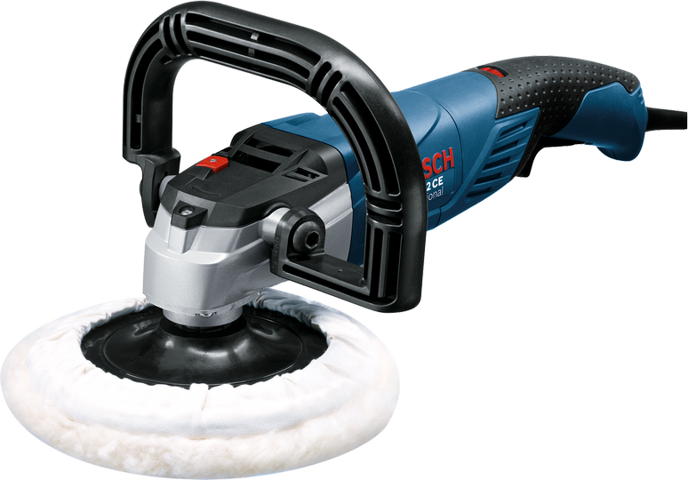

**INTENDED USE**

* The machine is intended for polishing and brushing metal and coated surfaces as well as for polishing stone without the use of water.

**Specification**

1. Rated input power - 1250 W
2. No-load speed - 750-3000 rpm
3. Weight - 2.5 kg
4. Rubber plate diameter - 100 mm
5. Grinding spindle thread - M 14

**Safety Precautions**

* Operations such as grinding or cutting-off are not recommended to be performed with this power tool.
* Regularly clean the power tool’s air vents.
* Do not run the power tool while carrying it at your side.
* Never lay the power tool down until the accessory has come to a complete stop.
* Hold the power tool by insulated gripping surfaces only, when performing an operation where the cutting accessory may contact hidden wiring or its own cord.
* Threaded mounting of accessories must match the grinder spindle thread.For accessories mounted by flanges,the arbour hole of the accessory must fit the locating diameter of the flange.
* Do not use accessories that require liquid coolants.
* Do not operate the power tool near flammable materials.

**7.Bosch professional GGS 28 LCE**

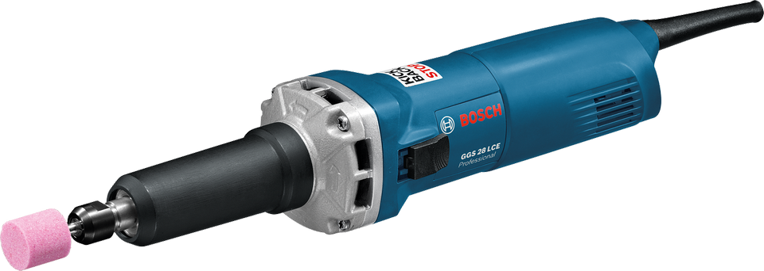

**INTENDED USE**

* The machine is designed for grinding and deburring metal using corundum grinding tools, as well as for working with sanding wheels.
* **GGS 8 CE**: The machine is additionally intended for brushing

and polishing metal.

**Specification**

1. Rated input power - 650 W
2. Power output - 380 W
3. No-load speed - 10000-30000 rpm
4. Weight - 1.6 kg
5. Spindle collar diameter - 43 mm
6. Switch - 2-way

**Safety Precautions**

* The arbour size of wheels, sanding drum or any other accessory must properly fit the spindle or col let of the power tool.
* Mandrel mounted wheels, sanding drums, cutters or other accessories must be fully inserted into the col let or chuck. The “overhang” or the length of the mandrel from the wheel to the col let must be minimal.
* Do not position your hand in line with and behind the rotating wheel.
* Do not “jam” the cut-off wheel or apply excessive pressure.
* Do not attempt to make an excessive depth of cut.
* Wear safety goggles.
* Use suitable detectors to determine if utility lines are hidden in the work area or call the local utility company for assistance.

**8.Bosch Professional GBM 13-2**

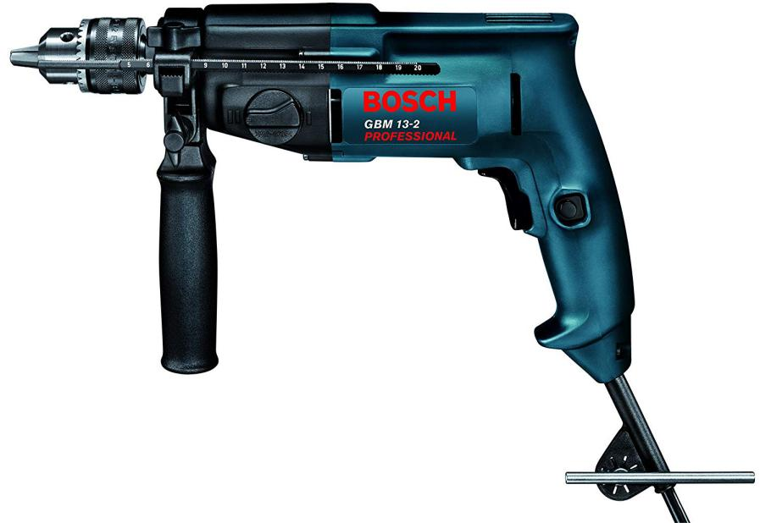

**INTENDED USE**

* Bosch Drills have been developed to execute the more different drilling types in: steel, aluminium, wood and others.
* By using other accessories, you will be able to do small jobs of: sanding, polishing, grinding, brushing, etc

**Specification**

1. Rated input power - 550 W
2. Power output - 285 W
3. No-load speed - 0 - 1000/1900 rpm
4. Weight - 1.9 kg
5. Rated speed - 550/1000 rpm
6. Max. torque - 11,5/6,0 Nm

**Safety Precautions**

* When working with the power tool, always hold it firmly with both hands and provide for a secure stance.
* Do not work materials containing asbestos.
* Switch off the power tool as soon as the tool insert jams. Be prepared for a high reaction torque, which will cause a kickback.
* Hold the power tool only by the insulated gripping surfaces when performing an operation where the cutting tool may contact hidden wiring or its own power cord.
* Do not force the power tool. Use the correct power tool for your application.
* Keep cutting tools sharp and clean.

1. **Bosch professional GWS 15-125 CIH**

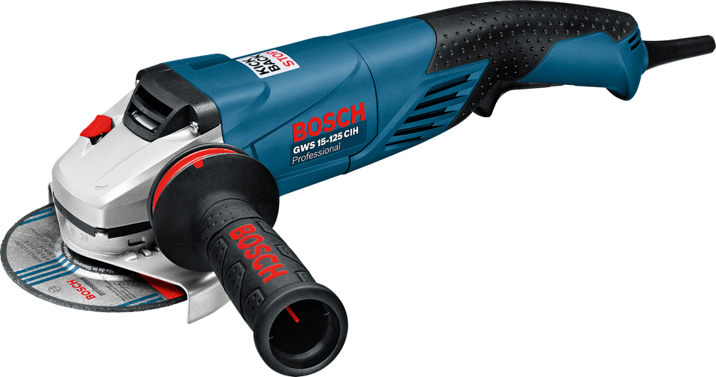

**INTENDED USE**

* The machine is intended for cutting, roughing and brushing of metal and stone materials without the use of water.
* For cutting with bonded abrasives, a special cutting guard (accessory) must be used.
* When cutting in stone, provide for sufficient dust extraction. With approved sanding tools, the machine can be used for sanding with sanding discs.

**Specification**

1. Rated input power - 1500 W
2. Power output - 860 W
3. No-load speed - 11,000 rpm
4. Weight - 2.3 kg
5. Switch - Tri -Control
6. Disk diameter - 125 mm
7. Grinding spindle thread - M 14

**Safety Precautions**

* Operations such as polishing are not recommended to be performed with this power tool.
* Do not use accessories which are not specifically designed and recommended by the tool manufacturer.
* Position the cord clear of the spinning accessory.
* Hold the power tool by insulated gripping surfaces only, when performing an operation where the cutting accessory may contact hidden wiring or its own cord.
* Never place your hand near the rotating accessory.
* Do not position your body in the area where power tool will move if kickback occurs.
* Use only wheel types that are recommended for your power tool and the specific guard designed for the selected wheel.
* Always use undamaged wheel flanges that are of correct size and shape for your selected wheel.
* Do not use excessively oversized sanding disc paper. Follow manufacturers recommendations, when selecting sanding paper.

1. **Bosch Professional GWS 14-125 CI**

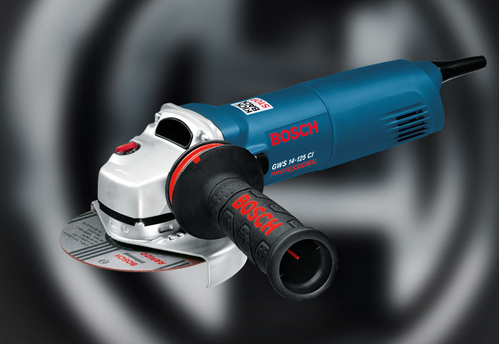

**INTENDED USE**

* The machine is intended for cutting, roughing and brushing of metal and stone materials without the use of water.
* For cutting with bonded abrasives, a special cutting guard (accessory) must be used.
* When cutting in stone, provide for sufficient dust extraction. With approved sanding tools, the machine can be used for sanding with sanding discs.

**Specification**

1. Rated input power - 1400 W
2. Power output - 820 W
3. No-load speed - 11,000 rpm
4. Weight - 2.2 kg
5. Disk diameter - 125 mm
6. Grinding spindle thread - M 14

**Safety Precautions**

* Operations such as polishing are not recommended to be performed with this power tool.
* The outside diameter and the thickness of your accessory must be within the capacity rating of your power tool.
* Never place your hand near the rotating accessory.
* Do not position your body in the area where power tool will move if kickback occurs.
* The grinding surface of the centre depressed wheels must be mounted below the plane of the guard lip.
* Always use undamaged wheel flanges that are of correct size and shape for your selected wheel.
* Do not use excessively oversized sanding disc paper. Follow manufacturers recommendations, when selecting sanding paper.

**11.Bosch professional GSB 13 RE**

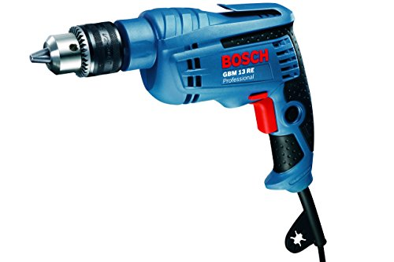

**INTENDED USE**

* The machine is intended for impact drilling in brick, concrete and stone as well as for drilling in wood, metal and plastic.
* Machines with electronic control and right/left rotation are also suitable for screw driving and thread-cutting.

**Specification**

1. Rated input power - 600 W
2. Power output - 301 W
3. No-load speed - 0 - 2800 rpm
4. Weight - 1.7 kg
5. Rated torque - 1,8 Nm
6. Impact rate at no load speed - 0- 44800 bpm

**Safety Precautions**

* Remove any adjusting key or wrench before turning the power tool on.
* Do not overreach. Keep proper footing and balance at
* all times.
* Wear ear protectors when impact drilling.
* Use auxiliary handle(s), if supplied with the tool.
* Hold power tool by insulated gripping surfaces, when performing an operation where the cutting accessory may contact hidden wiring or its own cord.
* When working with the machine, always hold it firmly with both hands and provide for a secure stance.
* Use suitable detectors to determine if utility lines are hidden in the work area or call the local utility company for assistance.

**12.Bosch Professional GST 85 PBE**

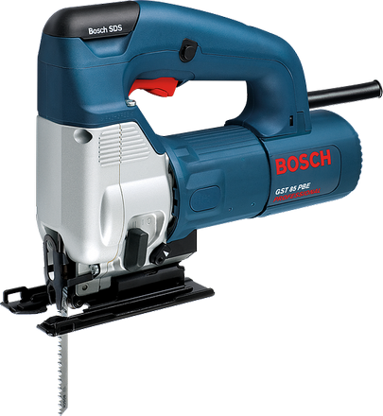

**INTENDED USE**

* The machine is intended for making separating cuts and cutouts in wood, plastic, metal, ceramic plates and rubber while resting firmly on the work piece.
* It is suitable for straight and curved cuts with mitre angles to 45°.
* The saw blade recommendations are to be observed.

**Specification**

1. Rated input power - 580 W
2. Weight - 2.4 kg
3. Stroke rate at no load - 500- 3100 spm
4. Cutting depth wood - 85 mm
5. Cutting depth aluminium - 20 mm

**Safety Precautions**

* Hold power tool by insulated gripping surfaces, when performing an operation where the cutting accessory may contact hidden wiring or its own cord.
* Keep hands away from the sawing range. Do not reach under the work piece.
* Pay attention that the base plate 8 rests securely on the material while sawing.
* When the cut is completed, switch off the machine and then pull the saw blade out of the cut only after it has come to a standstill.
* Use only undamaged saw blades that are in perfect condition.
* Do not brake the saw blade to a stop by applying side pressure after switching off.
* Always wait until the machine has come to a complete stop before placing it down.

1. **Bosch Professional GBG 60-20**

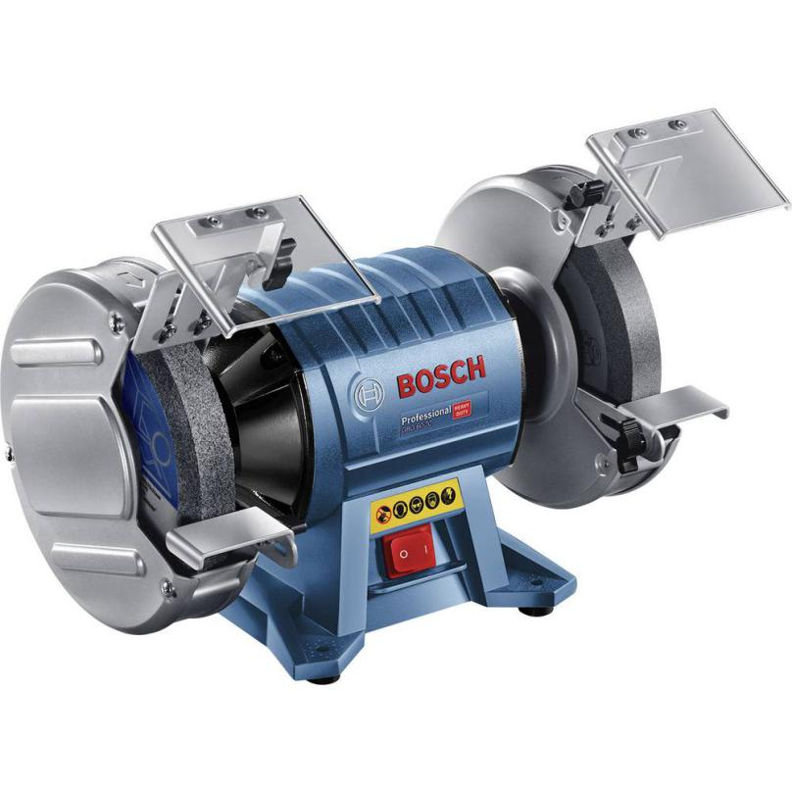

**INTENDED USE**

* The machine is intended for sharpening tools as well as for grinding and deburring metal.
* The machine may only be used for short-time operation (60 min. max).

**Specification**

1. Rated input power - 600 W
2. Grit - 24 , 60
3. No-load speed - 3600 rpm
4. Weight - 15 kg
5. Grinding wheel bore - 32 mm
6. Grinding wheel diameter - 200 mm

**Safety Precautions**

* Do not use a damaged accessory. Before each use, check the grinding wheel for chips and cracks. If the machine or application tool is dropped, inspect for damage or install an undamaged application tool. After inspecting and installing the application tool, position yourself and bystanders away from the plane of the rotating application tool and run the power tool at maximum no-load speed for one minute.
* Never grind on the sides of grinding wheels.
* The rated speed of the accessory must be at least equal to the maximum speed marked on the power tool.
* Wear safety goggles.
* Store the power tool and the application tool in a safe manner when not being used. The storage location must be dry and lockable.
* Check the cable regularly and have a damaged cable repaired only through an authorized customer service agent for Bosch power tools. Replace damaged extension cables.

1. **Bosch Professional GTS 10 J**

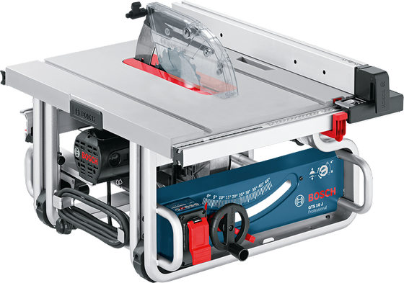

**INTENDED USE**

* The power tool is intended as a stationary machine for making straight lengthways and cross ways cuts in hard and softwood, as well as in particle and fibre board.
* In this, mitre angles from –60° to +60 ° as well as bevel angles from –2° to 47° are possible.
* When using appropriate saw blades, sawing aluminium profiles and plastic is also possible.

**Specification**

1. Table size - 642 x 572 mm
2. Saw blade diameter - 25 mm
3. No-load speed - 3650 rpm
4. Weight - 26 kg
5. Cutting height - 79 mm
6. Saw blade bore diameter - 30 mm

**Safety Precautions**

* Never stand on the power tool.
* Take care that the blade guard operates properly and can move freely.
* Keep hands away from the cutting area while the machine is running.
* Never reach behind the saw blade in order to hold the work piece, remove saw dust/wood chips or for any other reason.
* Operate the power tool only when the work area to the work piece is clear of any adjusting tools, wood chips, etc.
* Never operate the machine without the insert plate. Replace a defective insert plate.
* Never leave the machine before it has come to a complete stop.